**LAB # 03**

**K-NEAREST NEIGHBOR (KNN) ALGORITHM**

**OBJECTIVE**

Implementing K-Nearest Neighbor (KNN) algorithm to classify the data set.

**Lab Tasks:**

**Weather Temperature Play**

#### 

1.Implement K-Nearest Neighbor (KNN) Algorithm on the above dataset in Fig 1 to predict whether the players can play or not when the weather is overcast and the temperature is mild.Also apply confusion Matrix.

Code:

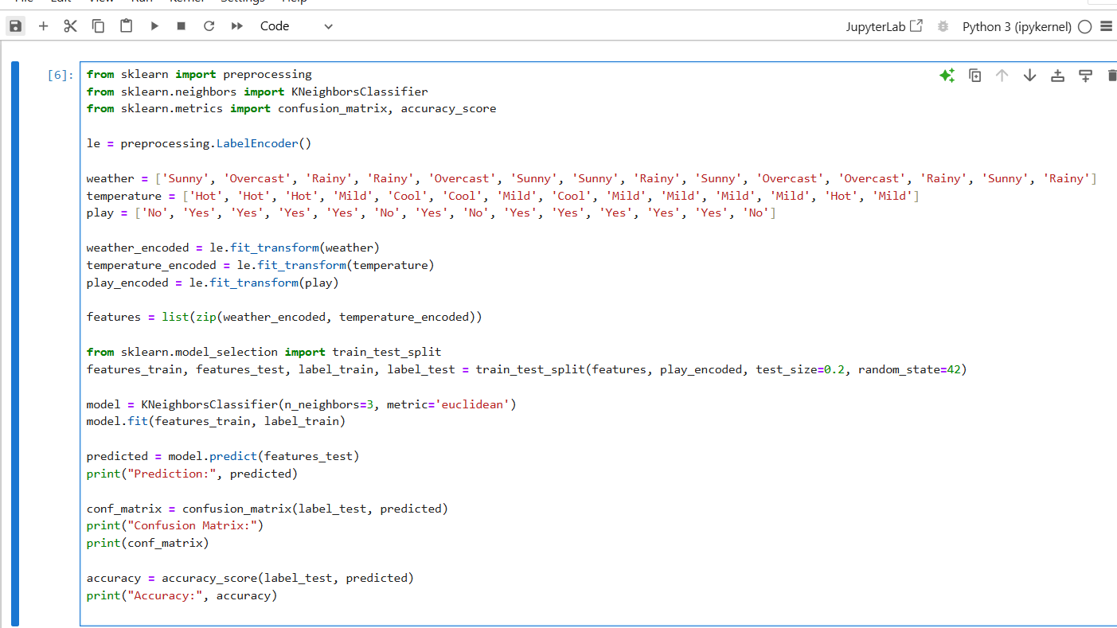

Output:

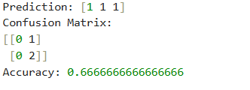

2.Here are 4 training samples. The two attributes are acid durability and strength. Now the factory produces a new tissue paper that passes laboratory test with X1=3 and X2=7. Predict the classification of this new tissue.

**X1= Acid durability (sec)**  **X2=Strength (kg/m2)** **Y=Classification**

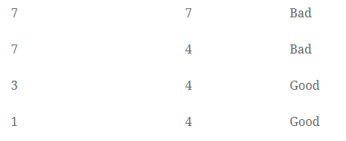

* Calculate the Euclidean Distance between the query instance and all the training samples. Coordinate of query instance is (3,7).

Suppose K = number of nearest neighbors = 3, sort the distances and determine nearest neighbors. Gather the class (Y) of the nearest neighbors. Use majority of the category of nearest neighbors as the prediction value of the query instance

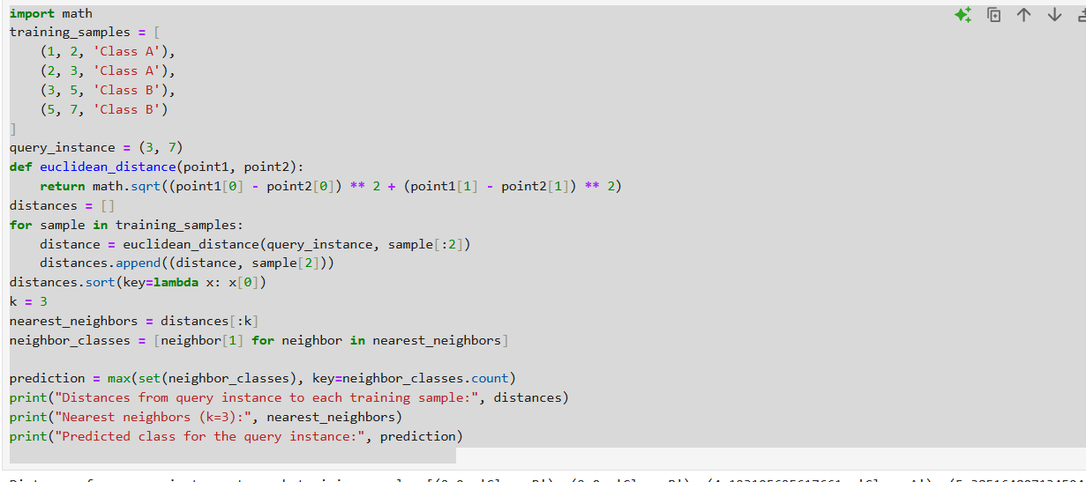

Output:

